電通二乙微處理器實驗 實驗結報

實驗名稱 | 溫濕度感測器
組別 | Lab12 | 組員 | 林楷桓

- 實驗目的


- 實驗步驟
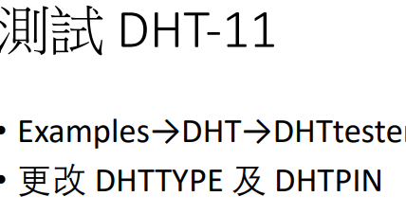
- 程式碼
01:
// Example testing sketch for various DHT humidity/temperature sensors
// Written by ladyada, public domain

// REQUIRES the following Arduino libraries:
// - DHT Sensor Library: https://github.com/adafruit/DHT-sensor-library
// - Adafruit Unified Sensor Lib: https://github.com/adafruit/Adafruit_Sensor

#include "DHT.h"

#define DHTPIN 2 // Digital pin connected to the DHT sensor
// Feather HUZZAH ESP8266 note: use pins 3, 4, 5, 12, 13 or 14 --
// Pin 15 can work but DHT must be disconnected during program upload.

// Uncomment whatever type you're using!
//#define DHTTYPE DHT11 // DHT 11
#define DHTTYPE DHT11 // DHT 22 (AM2302), AM2321
//#define DHTTYPE DHT21 // DHT 21 (AM2301)

// Connect pin 1 (on the left) of the sensor to +5V
// NOTE: If using a board with 3.3V logic like an Arduino Due connect pin 1
// to 3.3V instead of 5V!
// Connect pin 2 of the sensor to whatever your DHTPIN is
// Connect pin 4 (on the right) of the sensor to GROUND
// Connect a 10K resistor from pin 2 (data) to pin 1 (power) of the sensor

// Initialize DHT sensor.
// Note that older versions of this library took an optional third parameter to
// tweak the timings for faster processors. This parameter is no longer needed
// as the current DHT reading algorithm adjusts itself to work on faster procs.
DHT dht(DHTPIN, DHTTYPE);

void setup() {
Serial.begin(9600);
Serial.println(F("DHTxx test!"));

dht.begin();
}

void loop() {
// Wait a few seconds between measurements.
delay(2000);

// Reading temperature or humidity takes about 250 milliseconds!
// Sensor readings may also be up to 2 seconds 'old' (its a very slow sensor)
float h = dht.readHumidity();
// Read temperature as Celsius (the default)
float t = dht.readTemperature();
// Read temperature as Fahrenheit (isFahrenheit = true)
float f = dht.readTemperature(true);

// Check if any reads failed and exit early (to try again).
if (isnan(h) || isnan(t) || isnan(f)) {
Serial.println(F("Failed to read from DHT sensor!"));
return;
}

// Compute heat index in Fahrenheit (the default)
float hif = dht.computeHeatIndex(f, h);
// Compute heat index in Celsius (isFahreheit = false)
float hic = dht.computeHeatIndex(t, h, false);

Serial.print(F("Humidity: "));
Serial.print(h);
Serial.print(F("% Temperature:"));
Serial.print(t);
Serial.print(("°C "));
Serial.print(f);
Serial.print(F("°F Heat index: "));
Serial.print(hic);
Serial.print(F("°C "));
Serial.print(hif);
Serial.println(F("°F"));
}

02:

#include "Arduino.h"
#include "LTimer.h"
#include "DHT.h"
#define DHTPIN 2
#define DHTTYPE DHT11
DHT dht(DHTPIN, DHTTYPE);
int led0 = 7;
int led1 = 6;
int val0 = 0;
int val1 = 0;

// instantiation
LTimer timer0(LTIMER_0);
LTimer timer1(LTIMER_1);

// callback function for timer0
void _callback0(void *usr_data)
{
val0 = !val0;

digitalWrite(led0, val0);
}

// callback function for timer1
void _callback1(void *usr_data)
{
val1 = !val1;

digitalWrite(led1, val1);
}

void setup() {
Serial.begin(9600);
Serial.println(F("DHTxx test!"));

dht.begin();
// initialization
timer0.begin();
timer1.begin();

// start the execution
timer0.start(500, LTIMER_REPEAT_MODE, _callback0, NULL);
timer1.start(250, LTIMER_REPEAT_MODE, _callback1, NULL);
}

void loop() {
// Wait a few seconds between measurements.
delay(2000);

// Reading temperature or humidity takes about 250 milliseconds!
// Sensor readings may also be up to 2 seconds 'old' (its a very slow sensor)
float h = dht.readHumidity();
// Read temperature as Celsius (the default)
float t = dht.readTemperature();
// Read temperature as Fahrenheit (isFahrenheit = true)
float f = dht.readTemperature(true);

// Check if any reads failed and exit early (to try again).
if (isnan(h) || isnan(t) || isnan(f)) {
Serial.println(F("Failed to read from DHT sensor!"));
return;
}

// Compute heat index in Fahrenheit (the default)
float hif = dht.computeHeatIndex(f, h);
// Compute heat index in Celsius (isFahreheit = false)
float hic = dht.computeHeatIndex(t, h, false);

Serial.print(F("Humidity: "));
Serial.print(h);
Serial.print(F("% Temperature:"));
Serial.print(t);
Serial.print(("°C "));
Serial.print(f);
Serial.print(F("°F Heat index: "));
Serial.print(hic);
Serial.print(F("°C "));
Serial.print(hif);
Serial.println(F("°F"));
}
03:
#include "Arduino.h"
#include "LTimer.h"
#include "DHT.h"

#include <LWiFi.h>
#include "MCS.h"

#define DHTPIN 2
#define DHTTYPE DHT11

#define _SSID "000"
#define _KEY "00000000"

MCSDevice mcs("DCQYOB0l", "rxs0JwStoK1QipOb");
MCSDisplayInteger temp("Temperature");
MCSDisplayInteger humid("Humidity");

DHT dht(DHTPIN, DHTTYPE);

LTimer timer1(LTIMER_1);
double h;
double t;

void _callback1(void *usr_data)
{

Serial.print(F("Humidity: "));
Serial.print(h);
Serial.print(F("% Temperature: "));
Serial.print(t);
Serial.println(F("°C "));
}
void setup()
{
Serial.begin(9600);
mcs.addChannel(temp);
mcs.addChannel(humid);
while(WL_CONNECTED != WiFi.status())
{
Serial.print("WiFi.begin(");
Serial.print(_SSID);
Serial.print(",");
Serial.print(_KEY);
Serial.println(")...");
WiFi.begin(_SSID, _KEY);
}
Serial.println("WiFi connected !!");

Serial.begin(9600);
dht.begin();
timer1.begin();
timer1.start(10000, LTIMER_REPEAT_MODE, _callback1, NULL);
}
void loop()
{
while (!mcs.connected())
{
mcs.connect();
if (mcs.connected()) { Serial.println("MCS 已重新連線"); }
}
mcs.process(100);
h = dht.readHumidity();
t = dht.readTemperature();

temp.set(t);
humid.set(h);
}

- 實驗結果及分析
01
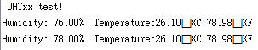

02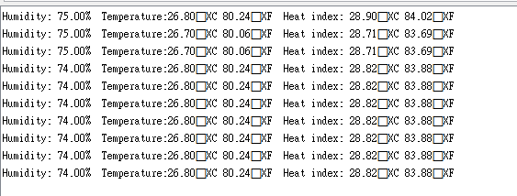
03
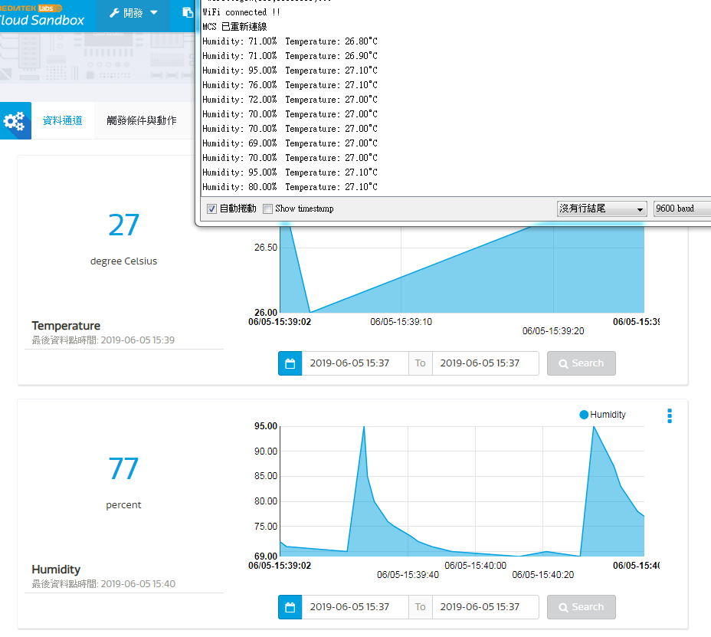
- 心得討論
下禮拜要考試了

